Accessory specifications

E-Ink Specifications
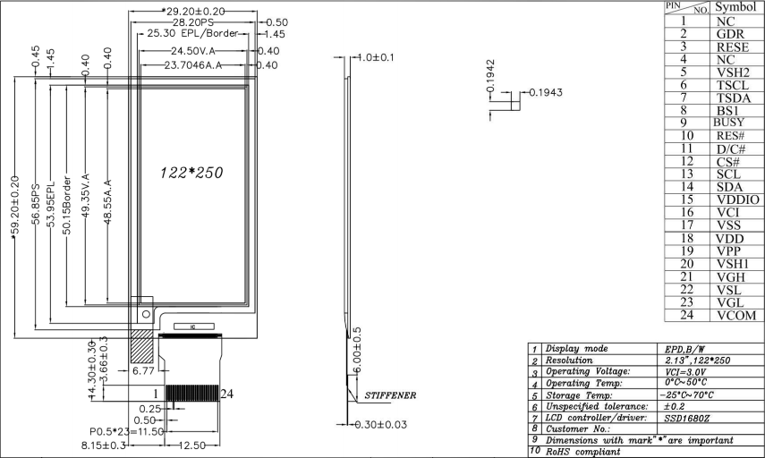

2000mAH Lithium Battery Specifications
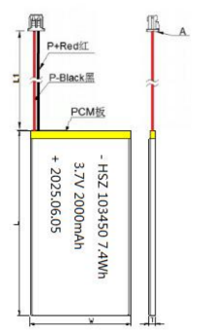
Project | Standard
Battery length | L≤52.5mm
Battery width | W≤34.5mm
Battery thickness | T≤10.3mm
Wire length | L1:60±5mm
- Wire specification | - 1571 26#Line
- Plug size | - 1.25-2P
- Connecting Wires:
- Red: connect to “+”;
- Black : connect to ground “—”

